**VISVESVARAYA TECHNOLOGICAL UNIVERSITY**

“JnanaSangama”, Belgaum -590014, Karnataka.



**LAB REPORT**

**on**

**ARTIFICIAL INTELLIGENCE**

*Submitted by*

**HARSHITHA R (1BM21CS075)**

***Under the Guidance of***

**Prof. Swathi Sridharan**

**Assistant Professor, BMSCE**

*in partial fulfilment for the award of the degree of*

**BACHELOR OF ENGINEERING**

in

**COMPUTER SCIENCE AND ENGINEERING**



**B.M.S. COLLEGE OF ENGINEERING**

**(Autonomous Institution under VTU)**

**BENGALURU-560019**

**November 2023-February 2024**

**B. M. S. College of Engineering,**

**Bull Temple Road, Bangalore 560019**

**(Affiliated To Visvesvaraya Technological University, Belgaum) Department of Computer Science and Engineering**



# CERTIFICATE

This is to certify that the Lab work entitled “**ARTIFICIAL INTELLIGENCE**” carried out by **HARSHITHA R(1BM21CS075)** , who is bonafide student of **B. M. S. College of Engineering.** It is in partial fulfilment for the award of **Bachelor of Engineering in Computer Science and Engineering** of the Visvesvaraya Technological University, Belgaum during the year 2023-24.

The Lab report has been approved as it satisfies the academic requirements in respect of **Artificial Intelligence - (22CS5PCAIN)** work prescribed for the said degree.

Prof. Swathi Sridharan Dr. Jyothi Nayak

Assistant professor Professor and Head

Department of CSE Department of CSE

BMSCE, Bengaluru BMSCE, Bengaluru

**B. M. S. COLLEGE OF ENGINEERING**

**DEPARTMENT OF COMPUTER SCIENCE AND**

**ENGINEERING**



***DECLARATION***

I, **Harshitha R(1BM21CS075)**, student of 5th Semester, B.E, Department of Computer Science and Engineering, B. M. S. College of Engineering, Bangalore, here by declare that, this lab report entitled " **Artificial Intelligence** " has been carried out by me under the guidance of Prof. Asha GR, Assistant Professor, Department of CSE, B. M. S. College of Engineering, Bangalore during the academic semester November-2023-February-2024.

I also declare that to the best of my knowledge and belief, the development reported here is not from part of any other report by any other students.

**TABLE OF CONTENTS**

|  |  |  |
| --- | --- | --- |
| **Sl.No** | **TITLE** | **Page No.** |
| 1 | Tic Tac Toe | 1-5 |
| 2 | 8 Puzzle using DFS | 6-7 |
| 3 | 8 Puzzle using IDDFS | 8-9 |
| 4 | 8 Puzzle using A* | 10-12 |
| 5 | Vacuum Cleaner | 13-14 |
| 6 | Knowledge Base Entailment | 15-16 |
| 7 | Knowledge Base Resolution | 17-18 |
| 8 | Unification | 19-21 |
| 9 | FOL to CNF | 22-23 |
| 10 | Forward Reasoning | 24-26 |

**PROGRAM 1**

**Aim:**

Implement Tic –Tac –Toe Game.

**Code:**

tic=[]

import random

def board(tic):

    for i in range(0,9,3):

        print("+"+"-"*29+"+")

        print("|"+" "*9+"|"+" "*9+"|"+" "*9+"|")

        print("|"+" "*3,tic[0+i]," "*3+"|"+" "*3,tic[1+i]," "*3+"|"+" "*3,tic[2+i]," "*3+"|")

        print("|"+" "*9+"|"+" "*9+"|"+" "*9+"|")

    print("+"+"-"*29+"+")

def update_comp():

    global tic,num

    for i in range(9):

        if tic[i]==i+1:

            num=i+1

            tic[num-1]='X'

            if winner(num-1)==False:

                #reverse the change

                tic[num-1]=num

            else:

                return

    for i in range(9):

        if tic[i]==i+1:

            num=i+1

            tic[num-1]='O'

            if winner(num-1)==True:

                tic[num-1]='X'

                return

            else:

                tic[num-1]=num

    num=random.randint(1,9)

    while num  not in tic:

        num=random.randint(1,9)

    else:

        tic[num-1]='X'

def update_user():

    global tic,num

    num=int(input("enter a number on the board :"))

    while num not in tic:

        num=int(input("enter a number on the board :"))

    else:

        tic[num-1]='O'

def winner(num):

    if tic[0]==tic[4] and tic[4]==tic[8] or tic[2]==tic[4] and tic[4]==tic[6]:

        return True

    if tic[num]==tic[num-3] and tic[num-3]==tic[num-6]:

        return True

    if tic[num//3*3]==tic[num//3*3+1] and tic[num//3*3+1]==tic[num//3*3+2]:

        return True

    return False

try:

    for i in range(1,10):

        tic.append(i)

    count=0

    #print(tic)

    board(tic)

    while count!=9:

        if count%2==0:

            print("computer's turn :")

            update_comp()

            board(tic)

            count+=1

        else:

            print("Your turn :")

            update_user()

            board(tic)

            count+=1

        if count>=5:

            if winner(num-1):

                print("winner is ",tic[num-1])

                break

            else:

                continue

except:

    print("\nerror\n")

**Output:**

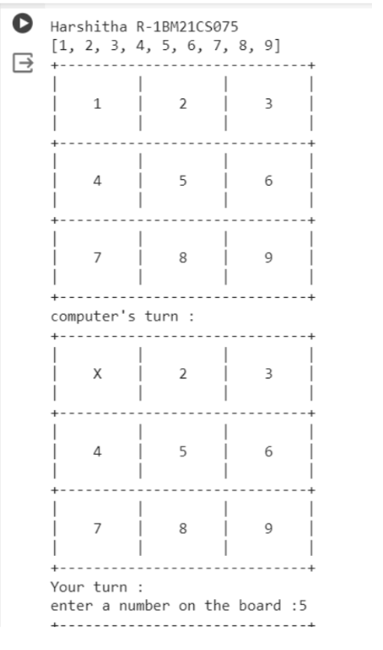

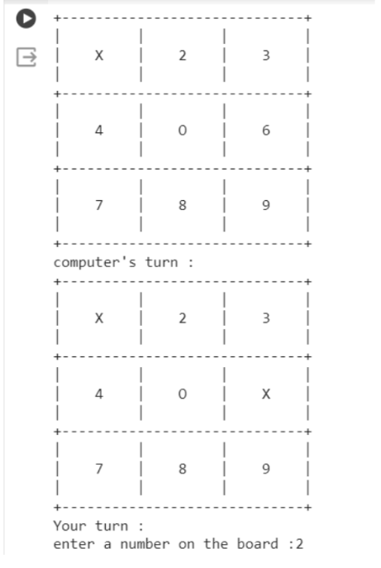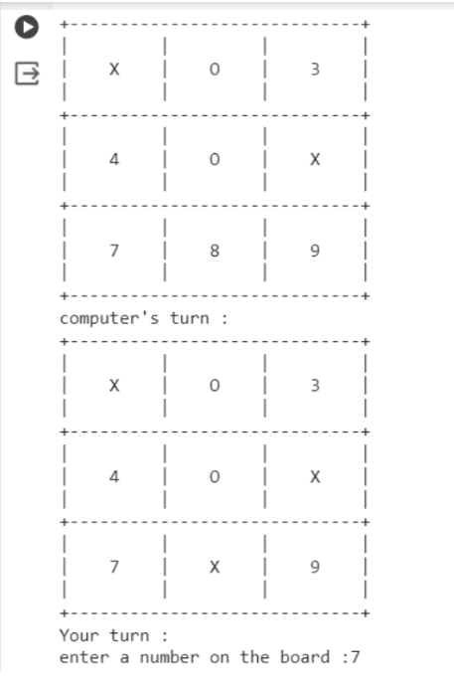

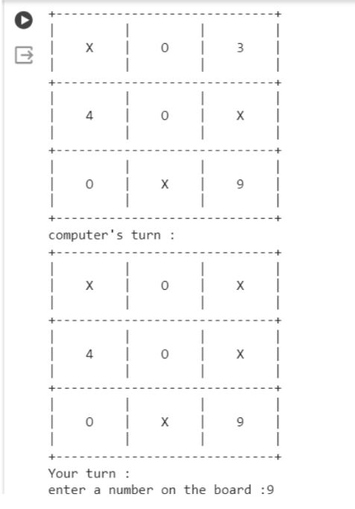

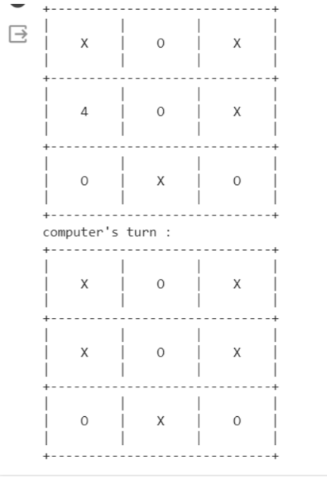

**PROGRAM 2**

**Aim:**

Solve 8 puzzle problems using BFS.

**Code:**

def bfs(src,target):

    queue=[]

    queue.append(src)

    exp=[]

    while len(queue)>0:

        source=queue.pop(0)

        #print("queue",queue)

        exp.append(source)

        print(source[0],'|',source[1],'|',source[2])

        print(source[3],'|',source[4],'|',source[5])

        print(source[6],'|',source[7],'|',source[8])

        print("-----------")

        if source==target:

            print("Success")

            return

        poss_moves_to_do=[]

        poss_moves_to_do=possible_moves(source,exp)

        #print("possible moves",poss_moves_to_do)

        for move in poss_moves_to_do:

            if move not in exp and move not in queue:

              #print("move",move)

              queue.append(move)

def possible_moves(state,visited_states):

    b=state.index(0)

    #direction array

    d=[]

    if b not in [0,1,2]:

        d.append('u')

    if b not in [6,7,8]:

        d.append('d')

    if b not in [0,3,6]:

        d.append('l')

    if b not in [2,5,8]:

        d.append('r')

    pos_moves_it_can=[]

    for i in d:

        pos_moves_it_can.append(gen(state,i,b))

    return [move_it_can for move_it_can in pos_moves_it_can if move_it_can not in visited_states]

def gen(state,m,b):

    temp=state.copy()

    if m=='d':

        temp[b+3],temp[b]=temp[b],temp[b+3]

    if m=='u':

        temp[b-3],temp[b]=temp[b],temp[b-3]

    if m=='l':

        temp[b-1],temp[b]=temp[b],temp[b-1]

    if m=='r':

        temp[b+1],temp[b]=temp[b],temp[b+1]

    return temp

src=[1,2,3,4,5,6,0,7,8]

target=[1,2,3,4,5,6,7,8,0]

bfs(src,target)

**Output**

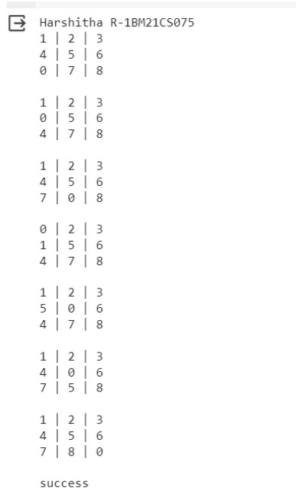

**PROGRAM 3**

**Aim:**

Implement Iterative deepening search algorithm. (8 puzzle problem)

**Code:**

def id_dfs(puzzle, goal, get_moves):

    import itertools

#get_moves -> possible_moves

    def dfs(route, depth):

        if depth == 0:

            return

        if route[-1] == goal:

            return route

        for move in get_moves(route[-1]):

            if move not in route:

                next_route = dfs(route + [move], depth - 1)

                if next_route:

                    return next_route

    for depth in itertools.count():

        route = dfs([puzzle], depth)

        if route:

            return route

def possible_moves(state):

    b = state.index(0)  # ) indicates White space -> so b has index of it.

    d = []  # direction

    if b not in [0, 1, 2]:

        d.append('u')

    if b not in [6, 7, 8]:

        d.append('d')

    if b not in [0, 3, 6]:

        d.append('l')

    if b not in [2, 5, 8]:

        d.append('r')

    pos_moves = []

    for i in d:

        pos_moves.append(generate(state, i, b))

    return pos_moves

def generate(state, m, b):

    temp = state.copy()

    if m == 'd':

        temp[b + 3], temp[b] = temp[b], temp[b + 3]

    if m == 'u':

        temp[b - 3], temp[b] = temp[b], temp[b - 3]

    if m == 'l':

        temp[b - 1], temp[b] = temp[b], temp[b - 1]

    if m == 'r':

        temp[b + 1], temp[b] = temp[b], temp[b + 1]

    return temp

# calling ID-DFS

initial = [1, 2, 3, 0, 4, 6, 7, 5, 8]

goal = [1, 2, 3, 4, 5, 6, 7, 8, 0]

route = id_dfs(initial, goal, possible_moves)

if route:

    print("Success!! It is possible to solve 8 Puzzle problem")

    print("Path:", route)

else:

    print("Failed to find a solution")

**Output:**



**PROGRAM 4**

**Aim:**

Implement A* search algorithm.

**Code:**

class Node:

    def __init__(self,data,level,fval):

        """ Initialize the node with the data, level of the node and the calculated fvalue """

        self.data = data

        self.level = level

        self.fval = fval

    def generate_child(self):

        """ Generate child nodes from the given node by moving the blank space

            either in the four directions {up,down,left,right} """

        x,y = self.find(self.data,'_')

        """ val_list contains position values for moving the blank space in either of

            the 4 directions [up,down,left,right] respectively. """

        val_list = [[x,y-1],[x,y+1],[x-1,y],[x+1,y]]

        children = []

        for i in val_list:

            child = self.shuffle(self.data,x,y,i[0],i[1])

            if child is not None:

                child_node = Node(child,self.level+1,0)

                children.append(child_node)

        return children

    def shuffle(self,puz,x1,y1,x2,y2):

        """ Move the blank space in the given direction and if the position value are out

            of limits the return None """

        if x2 >= 0 and x2 < len(self.data) and y2 >= 0 and y2 < len(self.data):

            temp_puz = []

            temp_puz = self.copy(puz)

            temp = temp_puz[x2][y2]

            temp_puz[x2][y2] = temp_puz[x1][y1]

            temp_puz[x1][y1] = temp

            return temp_puz

        else:

            return None

    def copy(self,root):

        """ Copy function to create a similar matrix of the given node"""

        temp = []

        for i in root:

            t = []

            for j in i:

                t.append(j)

            temp.append(t)

        return temp

    def find(self,puz,x):

        """ Specifically used to find the position of the blank space """

        for i in range(0,len(self.data)):

            for j in range(0,len(self.data)):

                if puz[i][j] == x:

                    return i,j

class Puzzle:

    def __init__(self,size):

        """ Initialize the puzzle size by the specified size,open and closed lists to empty """

        self.n = size

        self.open = []

        self.closed = []

    def accept(self):

        """ Accepts the puzzle from the user """

        puz = []

        for i in range(0,self.n):

            temp = input().split(" ")

            puz.append(temp)

        return puz

    def f(self,start,goal):

        """ Heuristic Function to calculate hueristic value f(x) = h(x) + g(x) """

        return self.h(start.data,goal)+start.level

    def h(self,start,goal):

        """ Calculates the different between the given puzzles """

        temp = 0

        for i in range(0,self.n):

            for j in range(0,self.n):

                if start[i][j] != goal[i][j] and start[i][j] != '_':

                    temp += 1

        return temp

    def process(self):

        """ Accept Start and Goal Puzzle state"""

        print("Enter the start state matrix \n")

        start = self.accept()

        print("Enter the goal state matrix \n")

        goal = self.accept()

        start = Node(start,0,0)

        start.fval = self.f(start,goal)

        """ Put the start node in the open list"""

        self.open.append(start)

        print("\n\n")

        while True:

            cur = self.open[0]

            print("")

            print("  | ")

            print("  | ")

            print(" \\\'/ \n")

            for i in cur.data:

                for j in i:

                    print(j,end=" ")

                print("")

            """ If the difference between current and goal node is 0 we have reached the goal node"""

            if(self.h(cur.data,goal) == 0):

                break

            for i in cur.generate_child():

                i.fval = self.f(i,goal)

                self.open.append(i)

            self.closed.append(cur)

            del self.open[0]

            """ sort the opne list based on f value """

            self.open.sort(key = lambda x:x.fval,reverse=False)

puz = Puzzle(3)

puz.process()

**Output**

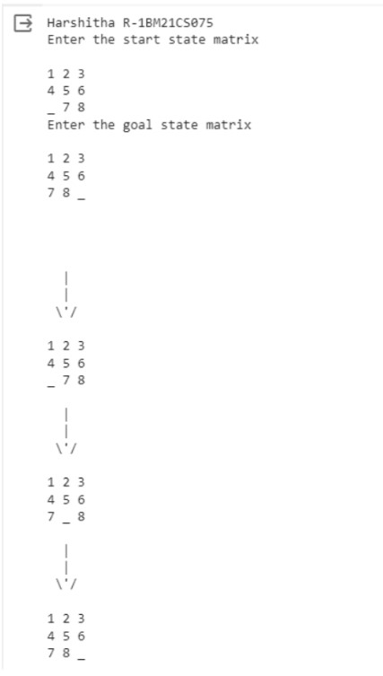

**PROGRAM 5**

**Aim:**

Implement vaccum cleaner agent.

**Code:**

def vacuum_world():

    # Initializing goal_state for four rooms

    # 0 indicates Clean and 1 indicates Dirty

    goal_state = {'A': 0, 'B': 0, 'C': 0, 'D': 0}

    cost = 0

    # User input for initial vacuum location and status of each room

    location_input = input("Enter Initial Location of Vacuum (A/B/C/D): ")

    print("Enter status of each room (1 - dirty, 0 - clean):")

    for room in goal_state:

        goal_state[room] = int(input(f"Status of Room {room}: "))

    print("Initial Location Condition: " + str(goal_state))

    # Function to clean a room

    def clean_room(room):

        nonlocal cost

        if goal_state[room] == 1:

            print(f"Cleaning Room {room}...")

            goal_state[room] = 0

            cost += 1  # Cost for cleaning

            print(f"Room {room} has been cleaned. Current cost: {cost}")

        else:

            print(f"Room {room} is already clean.")

    # Cleaning logic

    rooms = ['A', 'B', 'C', 'D']

    current_index = rooms.index(location_input)

    # Clean all rooms starting from the initial location

    for i in range(current_index, len(rooms)):

        clean_room(rooms[i])

    # Clean remaining rooms (if the initial location was not 'A')

    for i in range(0, current_index):

        clean_room(rooms[i])

    # Output final state and performance measure

    print("Final State of Rooms: " + str(goal_state))

    print("Performance Measurement (Total Cost): " + str(cost+4))

vacuum_world()

**Output**

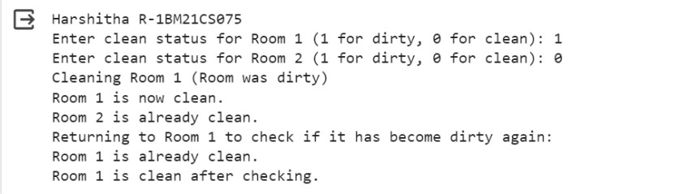

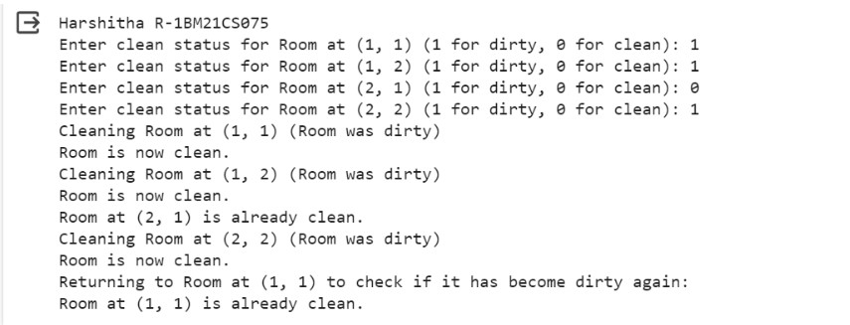

**PROGRAM 6**

**Aim:**

Create a knowledge base using prepositional logic and show that the given query entails the knowledge base or not.

**Code:**

from sympy import symbols, And, Not, Implies, satisfiable

def create_knowledge_base():

    # Define propositional symbols

    p = symbols('p')

    q = symbols('q')

    r = symbols('r')

    # Define knowledge base using logical statements

    knowledge_base = And(

        Implies(p, q),        # If p then q

        Implies(q, r),        # If q then r

        Not(r)                # Not r

    )

    return knowledge_base

def query_entails(knowledge_base, query):

    # Check if the knowledge base entails the query

    entailment = satisfiable(And(knowledge_base, Not(query)))

    # If there is no satisfying assignment, then the query is entailed

    return not entailment

if __name__ == "__main__":

    # Create the knowledge base

    kb = create_knowledge_base()

    # Define a query

    query = symbols('p')

    # Check if the query entails the knowledge base

    result = query_entails(kb, query)

    # Display the results

    print("Knowledge Base:", kb)

    print("Query:", query)

    print("Query entails Knowledge Base:", result)

**Output**

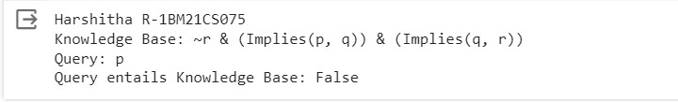

**PROGRAM 7**

**Aim:**

Create a knowledge base using prepositional logic and prove the given query using resolution

**Code:**

import re

def main(rules, goal):

    rules = rules.split(' ')

    steps = resolve(rules, goal)

    print('\nStep\t|Clause\t|Derivation\t')

    print('-' * 30)

    i = 1

    for step in steps:

        print(f' {i}.\t| {step}\t| {steps[step]}\t')

        i += 1

def negate(term):

    return f'~{term}' if term[0] != '~' else term[1]

def reverse(clause):

    if len(clause) > 2:

        t = split_terms(clause)

        return f'{t[1]}v{t[0]}'

    return ''

def split_terms(rule):

    exp = '(~*[PQRS])'

    terms = re.findall(exp, rule)

    return terms

split_terms('~PvR')

def contradiction(goal, clause):

    contradictions = [ f'{goal}v{negate(goal)}', f'{negate(goal)}v{goal}']

    return clause in contradictions or reverse(clause) in contradictions

def resolve(rules, goal):

    temp = rules.copy()

    temp += [negate(goal)]

    steps = dict()

    for rule in temp:

        steps[rule] = 'Given.'

    steps[negate(goal)] = 'Negated conclusion.'

    i = 0

    while i < len(temp):

        n = len(temp)

        j = (i + 1) % n

        clauses = []

        while j != i:

            terms1 = split_terms(temp[i])

            terms2 = split_terms(temp[j])

            for c in terms1:

                if negate(c) in terms2:

                    t1 = [t for t in terms1 if t != c]

                    t2 = [t for t in terms2 if t != negate(c)]

                    gen = t1 + t2

                    if len(gen) == 2:

                        if gen[0] != negate(gen[1]):

                            clauses += [f'{gen[0]}v{gen[1]}']

                        else:

                            if contradiction(goal,f'{gen[0]}v{gen[1]}'):

                                temp.append(f'{gen[0]}v{gen[1]}')

                                steps[''] = f"Resolved {temp[i]} and {temp[j]} to {temp[-1]}, which is in turn null. \

                                \nA contradiction is found when {negate(goal)} is assumed as true. Hence, {goal} is true."

                                return steps

                    elif len(gen) == 1:

                        clauses += [f'{gen[0]}']

                    else:

                        if contradiction(goal,f'{terms1[0]}v{terms2[0]}'):

                            temp.append(f'{terms1[0]}v{terms2[0]}')

                            steps[''] = f"Resolved {temp[i]} and {temp[j]} to {temp[-1]}, which is in turn null. \

                            \nA contradiction is found when {negate(goal)} is assumed as true. Hence, {goal} is true."

                            return steps

            for clause in clauses:

                if clause not in temp and clause != reverse(clause) and reverse(clause) not in temp:

                    temp.append(clause)

                    steps[clause] = f'Resolved from {temp[i]} and {temp[j]}.'

            j = (j + 1) % n

        i += 1

    return steps

rules = 'Rv~P Rv~Q ~RvP ~RvQ' #(P^Q)<=>R : (Rv~P)v(Rv~Q)^(~RvP)^(~RvQ)

goal = 'R'

main(rules, goal)

**Output**

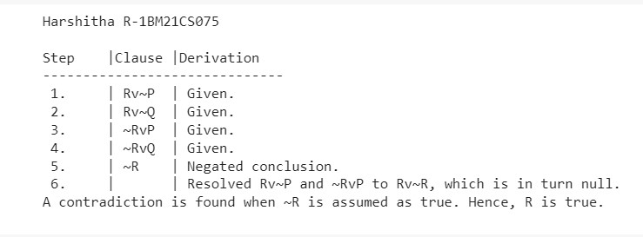

**PROGRAM 8**

**Aim:**

Implement unification in first order logic

**Code:**

import re

def getAttributes(expression):

    expression = expression.split("(")[1:]

    expression = "(".join(expression)

    expression = expression[:-1]

    expression = re.split("(?<!\(.),(?!.\))", expression)

    return expression

def getInitialPredicate(expression):

    return expression.split("(")[0]

def isConstant(char):

    return char.isupper() and len(char) == 1

def isVariable(char):

    return char.islower() and len(char) == 1

def replaceAttributes(exp, old, new):

    attributes = getAttributes(exp)

    for index, val in enumerate(attributes):

        if val == old:

            attributes[index] = new

    predicate = getInitialPredicate(exp)

    return predicate + "(" + ",".join(attributes) + ")"

def apply(exp, substitutions):

    for substitution in substitutions:

        new, old = substitution

        exp = replaceAttributes(exp, old, new)

    return exp

def checkOccurs(var, exp):

    if exp.find(var) == -1:

        return False

    return True

def getFirstPart(expression):

    attributes = getAttributes(expression)

    return attributes[0]

def getRemainingPart(expression):

    predicate = getInitialPredicate(expression)

    attributes = getAttributes(expression)

    newExpression = predicate + "(" + ",".join(attributes[1:]) + ")"

    return newExpression

def unify(exp1, exp2):

    if exp1 == exp2:

        return []

    if isConstant(exp1) and isConstant(exp2):

        if exp1 != exp2:

            return False

    if isConstant(exp1):

        return [(exp1, exp2)]

    if isConstant(exp2):

        return [(exp2, exp1)]

    if isVariable(exp1):

        if checkOccurs(exp1, exp2):

            return False

        else:

            return [(exp2, exp1)]

    if isVariable(exp2):

        if checkOccurs(exp2, exp1):

            return False

        else:

            return [(exp1, exp2)]

    if getInitialPredicate(exp1) != getInitialPredicate(exp2):

        print("Predicates do not match. Cannot be unified")

        return False

    attributeCount1 = len(getAttributes(exp1))

    attributeCount2 = len(getAttributes(exp2))

    if attributeCount1 != attributeCount2:

        return False

    head1 = getFirstPart(exp1)

    head2 = getFirstPart(exp2)

    initialSubstitution = unify(head1, head2)

    if not initialSubstitution:

        return False

    if attributeCount1 == 1:

        return initialSubstitution

    tail1 = getRemainingPart(exp1)

    tail2 = getRemainingPart(exp2)

    if initialSubstitution != []:

        tail1 = apply(tail1, initialSubstitution)

        tail2 = apply(tail2, initialSubstitution)

    remainingSubstitution = unify(tail1, tail2)

    if not remainingSubstitution:

        return False

    initialSubstitution.extend(remainingSubstitution)

    return initialSubstitution

exp1 = "knows(X)"

exp2 = "knows(Richard)"

substitutions = unify(exp1, exp2)

print("Substitutions:")

print(substitutions)

**Output**

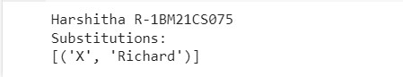

**PROGRAM 9**

**Aim:**

Convert a given first order logic statement into Conjunctive Normal Form (CNF).

**Code:**

def getAttributes(string):

    expr = '\([^)]+\)'

    matches = re.findall(expr, string)

    return [m for m in str(matches) if m.isalpha()]

def getPredicates(string):

    expr = '[a-z~]+\([A-Za-z,]+\)'

    return re.findall(expr, string)

def DeMorgan(sentence):

    string = ''.join(list(sentence).copy())

    string = string.replace('~~','')

    flag = '[' in string

    string = string.replace('~[','')

    string = string.strip(']')

    for predicate in getPredicates(string):

        string = string.replace(predicate, f'~{predicate}')

    s = list(string)

    for i, c in enumerate(string):

        if c == '|':

            s[i] = '&'

        elif c == '&':

            s[i] = '|'

    string = ''.join(s)

    string = string.replace('~~','')

    return f'[{string}]' if flag else string

def Skolemization(sentence):

    SKOLEM_CONSTANTS = [f'{chr(c)}' for c in range(ord('A'), ord('Z')+1)]

    statement = ''.join(list(sentence).copy())

    matches = re.findall('[∀∃].', statement)

    for match in matches[::-1]:

        statement = statement.replace(match, '')

        statements = re.findall('\[\[[^]]+\]]', statement)

        for s in statements:

            statement = statement.replace(s, s[1:-1])

        for predicate in getPredicates(statement):

            attributes = getAttributes(predicate)

            if ''.join(attributes).islower():

                statement = statement.replace(match[1],SKOLEM_CONSTANTS.pop(0))

            else:

                aL = [a for a in attributes if a.islower()]

                aU = [a for a in attributes if not a.islower()][0]

                statement = statement.replace(aU, f'{SKOLEM_CONSTANTS.pop(0)}({aL[0] if len(aL) else match[1]})')

    return statement

import re

def fol_to_cnf(fol):

    statement = fol.replace("<=>", "_")

    while '_' in statement:

        i = statement.index('_')

        new_statement = '[' + statement[:i] + '=>' + statement[i+1:] + ']&['+ statement[i+1:] + '=>' + statement[:i] + ']'

        statement = new_statement

    statement = statement.replace("=>", "-")

    expr = '\[([^]]+)\]'

    statements = re.findall(expr, statement)

    for i, s in enumerate(statements):

        if '[' in s and ']' not in s:

            statements[i] += ']'

    for s in statements:

        statement = statement.replace(s, fol_to_cnf(s))

    while '-' in statement:

        i = statement.index('-')

        br = statement.index('[') if '[' in statement else 0

        new_statement = '~' + statement[br:i] + '|' + statement[i+1:]

        statement = statement[:br] + new_statement if br > 0 else new_statement

    while '~∀' in statement:

        i = statement.index('~∀')

        statement = list(statement)

        statement[i], statement[i+1], statement[i+2] = '∃', statement[i+2], '~'

        statement = ''.join(statement)

    while '~∃' in statement:

        i = statement.index('~∃')

        s = list(statement)

        s[i], s[i+1], s[i+2] = '∀', s[i+2], '~'

        statement = ''.join(s)

    statement = statement.replace('~[∀','[~∀')

    statement = statement.replace('~[∃','[~∃')

    expr = '(~[∀|∃].)'

    statements = re.findall(expr, statement)

    for s in statements:

        statement = statement.replace(s, fol_to_cnf(s))

    expr = '~\[[^]]+\]'

    statements = re.findall(expr, statement)

    for s in statements:

        statement = statement.replace(s, DeMorgan(s))

    return statement

print(Skolemization(fol_to_cnf("animal(y)<=>loves(x,y)")))

print(Skolemization(fol_to_cnf("∀x[∀y[animal(y)=>loves(x,y)]]=>[∃z[loves(z,x)]]")))

print(fol_to_cnf("[american(x)&weapon(y)&sells(x,y,z)&hostile(z)]=>criminal(x)"))

**Output**

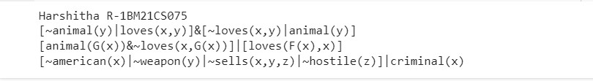

**PROGRAM 10**

**Aim:**

Create a knowledge base consisting of first order logic statements and prove the given query using forward reasoning.

**Code:**

import re

def isVariable(x):

    return len(x) == 1 and x.islower() and x.isalpha()

def getAttributes(string):

    expr = '\([^)]+\)'

    matches = re.findall(expr, string)

    return matches

def getPredicates(string):

    expr = '([a-z~]+)\([^&|]+\)'

    return re.findall(expr, string)

class Fact:

    def __init__(self, expression):

        self.expression = expression

        predicate, params = self.splitExpression(expression)

        self.predicate = predicate

        self.params = params

        self.result = any(self.getConstants())

    def splitExpression(self, expression):

        predicate = getPredicates(expression)[0]

        params = getAttributes(expression)[0].strip('()').split(',')

        return [predicate, params]

    def getResult(self):

        return self.result

    def getConstants(self):

        return [None if isVariable(c) else c for c in self.params]

    def getVariables(self):

        return [v if isVariable(v) else None for v in self.params]

    def substitute(self, constants):

        c = constants.copy()

        f = f"{self.predicate}({','.join([constants.pop(0) if isVariable(p) else p for p in self.params])})"

        return Fact(f)

class Implication:

    def __init__(self, expression):

        self.expression = expression

        l = expression.split('=>')

        self.lhs = [Fact(f) for f in l[0].split('&')]

        self.rhs = Fact(l[1])

    def evaluate(self, facts):

        constants = {}

        new_lhs = []

        for fact in facts:

            for val in self.lhs:

                if val.predicate == fact.predicate:

                    for i, v in enumerate(val.getVariables()):

                        if v:

                            constants[v] = fact.getConstants()[i]

                    new_lhs.append(fact)

        predicate, attributes = getPredicates(self.rhs.expression)[0], str(getAttributes(self.rhs.expression)[0])

        for key in constants:

            if constants[key]:

                attributes = attributes.replace(key, constants[key])

        expr = f'{predicate}{attributes}'

        return Fact(expr) if len(new_lhs) and all([f.getResult() for f in new_lhs]) else None

class KB:

    def __init__(self):

        self.facts = set()

        self.implications = set()

    def tell(self, e):

        if '=>' in e:

            self.implications.add(Implication(e))

        else:

            self.facts.add(Fact(e))

        for i in self.implications:

            res = i.evaluate(self.facts)

            if res:

                self.facts.add(res)

    def query(self, e):

        facts = set([f.expression for f in self.facts])

        i = 1

        print(f'Querying {e}:')

        for f in facts:

            if Fact(f).predicate == Fact(e).predicate:

                print(f'\t{i}. {f}')

                i += 1

    def display(self):

        print("All facts: ")

        for i, f in enumerate(set([f.expression for f in self.facts])):

            print(f'\t{i+1}. {f}')

kb = KB()

kb.tell('missile(x)=>weapon(x)')

kb.tell('missile(M1)')

kb.tell('enemy(x,America)=>hostile(x)')

kb.tell('american(West)')

kb.tell('enemy(Nono,America)')

kb.tell('owns(Nono,M1)')

kb.tell('missile(x)&owns(Nono,x)=>sells(West,x,Nono)')

kb.tell('american(x)&weapon(y)&sells(x,y,z)&hostile(z)=>criminal(x)')

kb.query('criminal(x)')

kb.display()

**Output:**

